科教所專題演講
演講題目：Assessment Alternatives
主講人：Dr. James A. Shymansky
日期：2007/03/14
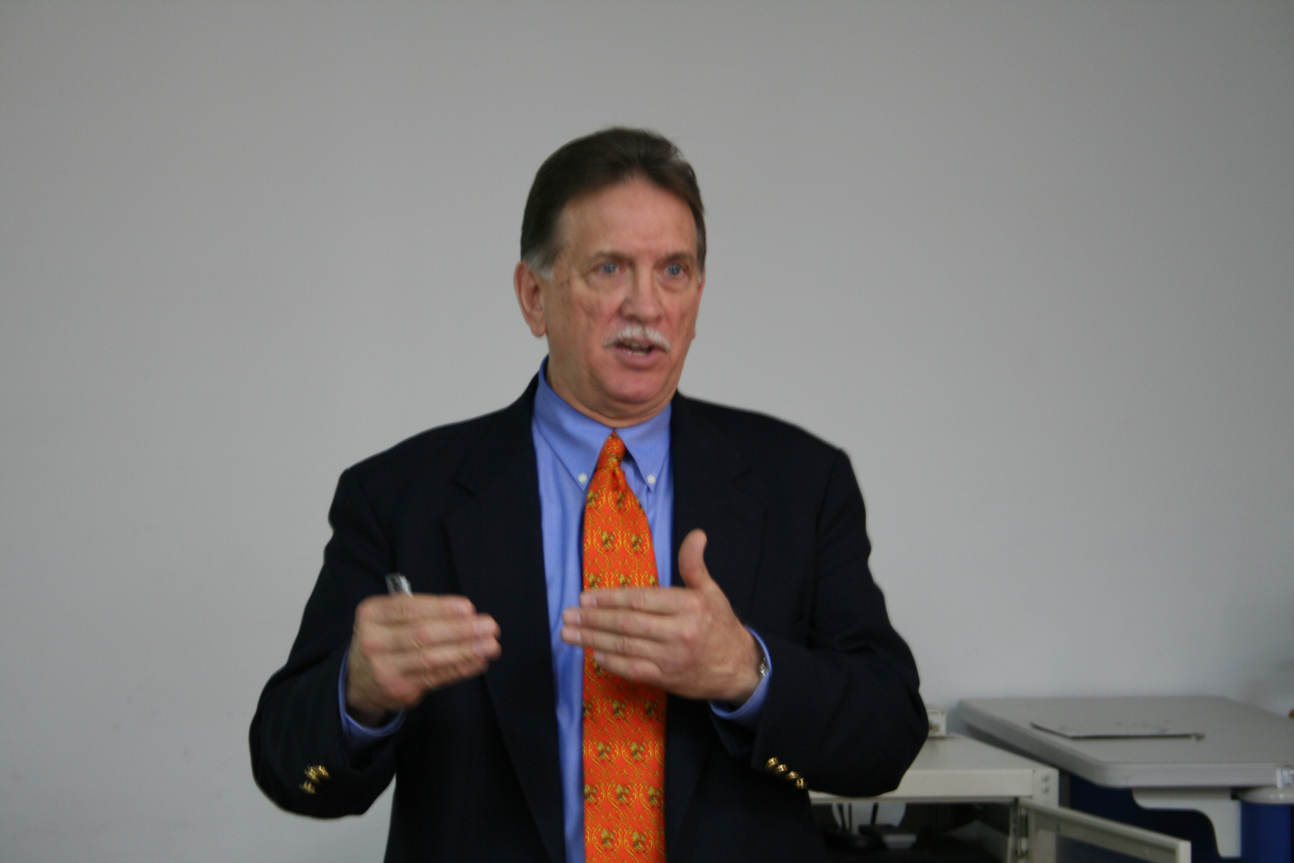
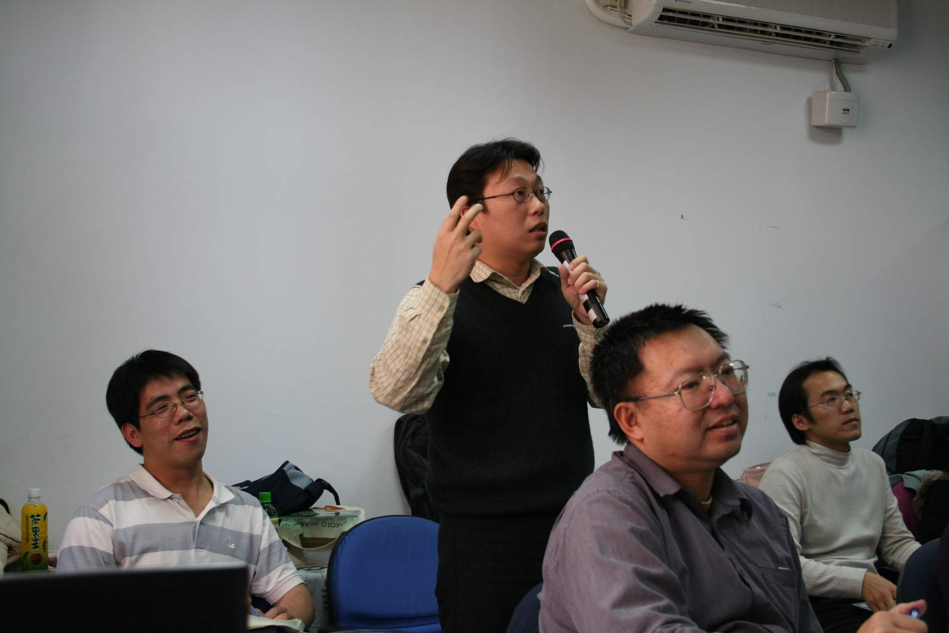
科教所專題演講
演講題目：The “Science Co-op” Project-The Impact of a Five-Year, K-6 Systemic Reform Effort on Elementary School Students’ Achievement in Science
主講人：Dr. James A. Shymansky
日期：2007/03/14
