科教所邀請國際學者演講照片
主 講 者：Dr. James A. Shymansky
(E. Desmond Lee Family Professor of Science Education / University of Missouri at St. Louis）
演講題目：Cooperative Learning-"The whole is greater than the sum of the parts"
日 期：2007/10/17
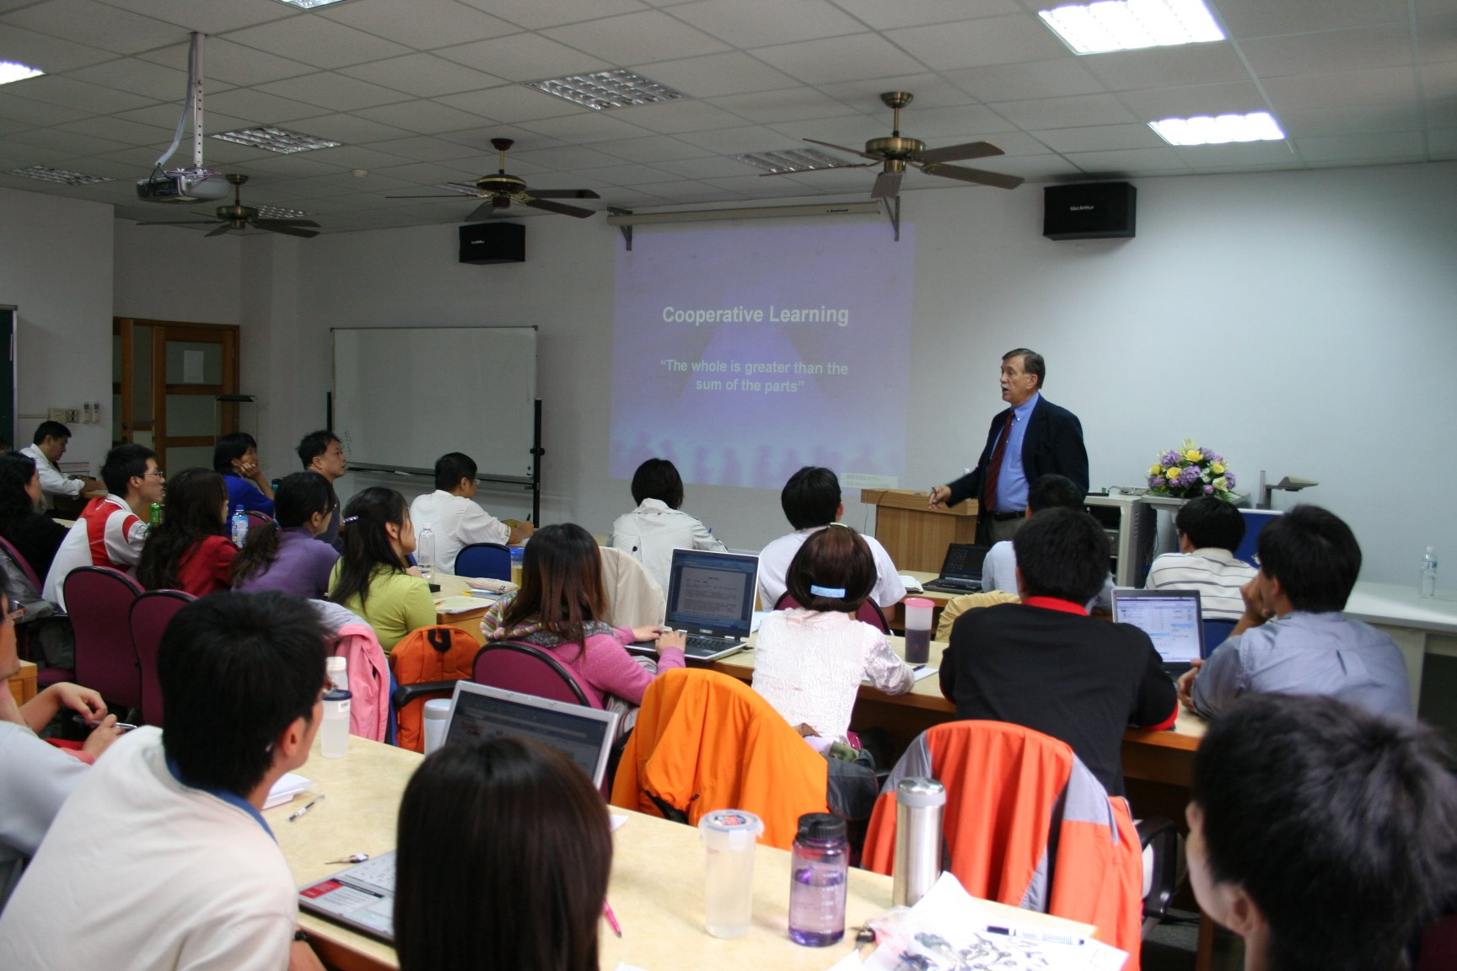
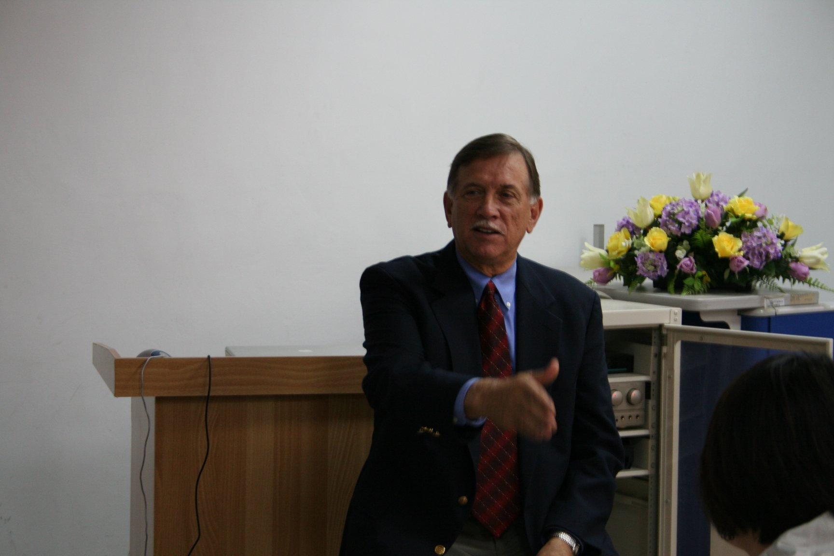
科教所邀請國際學者演講照片
主 講 者：Dr. James A. Shymansky
(E. Desmond Lee Family Professor of Science Education / University of Missouri at St. Louis）
演講題目：Cooperative Learning-"The whole is greater than the sum of the parts"
日 期：2007/10/17
